Mandatory Experiment 4.7

An iodine / thiosulfate titration

Student Material

Theory

Aqueous iodine solutions normally contain potassium iodide (KI), which acts to keep the iodine in solution. This is due to the fact that an equilibrium is set up as follows:
I₂ + I⁻ I₃⁻
I₃⁻ is much more soluble than I₂ and it is as I₃⁻ the iodine is kept in solution.

In this experiment, a standard (0.06 M) solution of iodine is generated in the conical flask by reacting a standard (0.02 M) solution of potassium iodate, for each titration, with excess potassium iodide. Iodine is liberated from iodate and iodide according to the equation:
IO₃⁻ + 5I⁻ + 6H⁺ → 3I₂ + 3H₂O

The iodine solution, which is a golden-brown colour, can be titrated against sodium thiosulfate solution. The sodium thiosulfate solution is placed in the burette and, as it is added to the conical flask, it reacts with the iodine and the colour of the solution fades. When it reaches a pale yellow colour, a few drops of a freshly prepared starch solution are added. The solution becomes blue-black, and the titration is continued until it goes colourless.

The titration reaction may be represented by the equation:

I₂ + 2S₂O₃²⁻ → 2I⁻ + S₄O₆²⁻

(Note that in this experiment a standard solution of iodine is used to standardise a sodium thiosulfate solution. But you also need to know that a standard solution of sodium thiosulfate can be used to standardise an iodine solution.)

Chemicals and Apparatus
0.02 M potassium iodate solution
0.5 M potassium iodide solution
Dilute (1M) sulfuric acid _{i}
Sodium thiosulfate solution
Starch indicator solution
Deionised (or distilled) water

Safety glasses
Pipette (25 cm³)
Pipette filler
Burette
Filter funnel
Conical flask (250 cm³)
White tile
White card
Graduated cylinders (100 cm³)
Retort stand
Boss-head
Clamp
Beakers (250 cm³)
Wash bottle

Procedure

NB: Wear your safety glasses.

- Wash the pipette, burette and conical flask with deionised water. Rinse the pipette with potassium iodate solution and the burette with the sodium thiosulfate solution.

- Using a pipette filler, fill the pipette with the potassium iodate solution, and transfer the contents of the pipette to the conical flask.

- Using graduated cylinders, add 20 cm³ of dilute sulfuric acid, followed by 10 cm³ of 0.5 M potassium iodide solution.

- Using a funnel, fill the burette with sodium thiosulfate solution, making sure that the part below the tap is filled before adjusting to zero.

- With the conical flask standing on a white tile, add the solution from the burette to the flask. Swirl the flask continuously and occasionally wash down the walls of the flask with deionised water using a wash bottle.

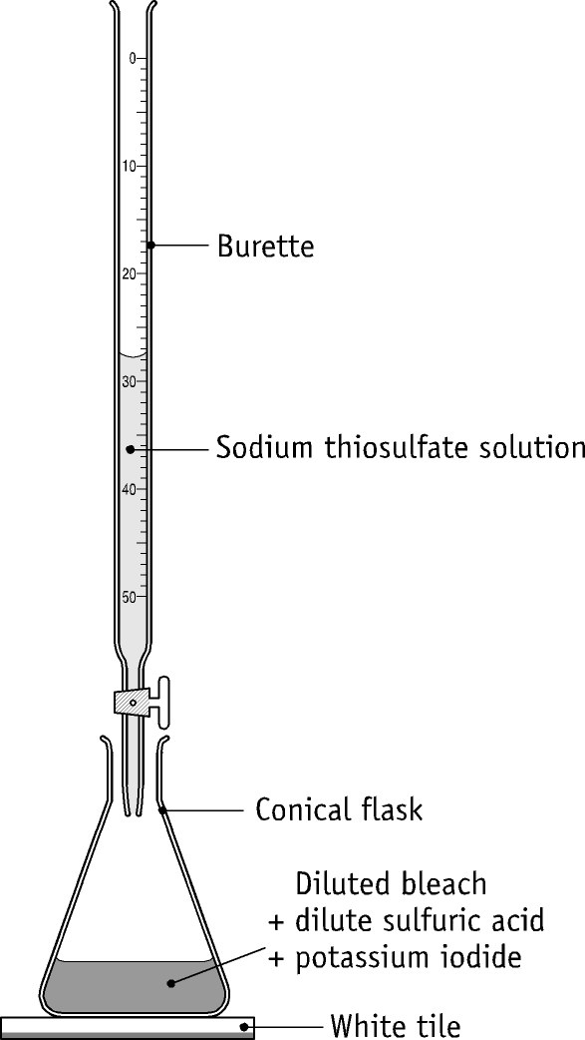

- Add a few drops of the starch indicator solution just prior to the end-point, when the colour of the solution fades to pale yellow. Upon addition of the indicator a blue-black colour should appear. The thiosulfate solution should now be added dropwise, with thorough swirling.

- The end-point of the titration is detected by a colour change from blue-black to colourless. Note the burette reading.

- Repeat the procedure, adding the sodium thiosulfate solution dropwise approaching the end-point until two titres agree to within 0.1 cm³.

- Calculate the concentration of the sodium thiosulfate solution.

Table of results

Copy this table into your practical report book.

Rough titre =
Second titre =
Third titre =
Average of accurate titres =

Volume of iodine solution used in each titration =
Concentration of iodine solution =
Concentration of sodium thiosulfate solution =

Questions relating to the experiment
- Why is hydrated sodium thiosulfate not suitable as a primary standard?

- Why are iodine solutions made up using potassium iodide solution?

- Why does starch solution have to be freshly prepared?

- Which of the three pieces of titration apparatus, the pipette, the burette or the conical flask, should not be rinsed with the solution it is to contain? Give a reason for your answer.

- Why is starch indicator added close to the end-point?

- What happens at the end-point?

Teacher Material

- Though sodium thiosulfate is available in a high state of purity, it is efflorescent, which creates some doubts over the water content in crystals from opened containers.

- Furthermore, solutions of thiosulfate are broken down by reaction with even trace quantities of acid resulting from absorption of atmospheric carbon dioxide by distilled water. Decomposition can also be catalysed by bacterial action if solutions are left stand for long periods.

- The stability of sodium thiosulfate solutions is enhanced if they are made up in boiled deionised water (to remove carbon dioxide) with sodium carbonate (0.1 g/l) added. Larger quantities of sodium carbonate cause too high an increase in pH and accelerate air oxidation of the thiosulfate ion.

- Solutions that can act as primary standards can be made up from anhydrous sodium thiosulfate. Anhydrous sodium thiosulfate can be prepared by refluxing sodium thiosulfate pentahydrate crystals in methanol for about 30 minutes. The anhydrous solid is isolated by filtration and dried in an oven at 70 ºC.

- When an iodine solution is being titrated against a standard solution of sodium thiosulfate, the solution should be shaken immediately before pipetting. The solution should be stoppered at all times when not in use.

- Solutions of sodium thiosulfate are best standardised using standard iodine solutions generated from potassium iodate, which is a good primary standard. Iodine is liberated from iodate and iodide according to the equation:
IO₃⁻ + 5I⁻ + 6H⁺ → 3I₂ + 3H₂O

- Standard solutions of iodine can also be made up using standard solutions of potassium manganate(VII). Iodine is liberated from iodide according to the equation:
2MnO₄⁻ + 10I⁻ + 16H⁺ → 2Mn²⁺ + 5I₂ + 8H₂O
This method has the disadvantage that potassium manganate(VII) solutions
deteriorate rapidly, which means that they have to be standardised shortly before
use.

- Iodine has low water solubility. Solutions for analytical purposes are made up in moderately concentrated potassium iodide solution. The iodine is taken into solution as the I₃⁻ ion according to the equation:
I₂ + I⁻ I₃⁻
The I₃⁻ ion is much more soluble in water than iodine is.

- Iodine solutions lack stability. Iodine is volatile and loss of iodine occurs when a vessel is open even for relatively short periods.

- Iodine slowly attacks organic materials - thus cork or rubber stoppers should not be used.

- Iodide is also susceptible to air oxidation in an acidic medium:
4I⁻ + 4H⁺ + O₂ → 2I₂ + 2H₂O

- Starch solutions are widely used in the detection of the end-point of iodine - thiosulfate titrations. The great advantage of starch lies in the fact that it gives a very definite colour change at the end-point. Without the starch indicator, the colour of the iodine solution in the conical flask near the end-point fades slowly from pale yellow to colourless. With the starch indicator added, the colour of the solution in the conical flask at the end-point changes suddenly from blue black to colourless.

- There are however a number of disadvantages in the use of starch as an indicator. Solid starch has a limited shelf life. Other disadvantages include the insolubility of starch in cold water and the fact that starch forms an insoluble complex with iodine. The latter problem precludes the addition of the indicator at the start of the titration and this is why the indicator is to be added just prior to the end point when the colour of the solution has changed to pale yellow. In addition to this there is sometimes a 'drift' in the end point, particularly when solutions are dilute.

Starch solution needs to be freshly prepared, as it deteriorates fairly quickly. However, if 0.5 g of salicylic acid is added to 50 cm³ of the solution immediately after it is made up, the solution will last for a few months.

- About 0.5 to 0.75 cm³ of starch solution is needed per titration, assuming a total volume of 50 to 75 cm³ in the titration flask at the end-point.

- A fuller description of titration procedure is to be found in the Student Material relating to Mandatory Experiment 4.2.

Preparation of reagents

0.02 M potassium iodate solution: Add 4.28 g potassium iodate to about 600 cm³ deionised water in a beaker, and stir to dissolve. Transfer the solution to a 1000 cm³ volumetric flask. Wash out the beaker with deionised water and add the washings to the volumetric flask. Then bring the total volume to 1000 cm³ using deionised water. The bottom of the meniscus should be resting on the mark. Stopper the volumetric flask and invert several times.

1 M sulfuric acid: (Always dilute sulfuric acid by adding the acid to water and not the other way round.) 56 cm³ of the concentrated acid is added slowly to about 700 cm³ of deionised water containing about 20 ice cubes. The mixture is stirred and made up to 1 litre in a volumetric flask with deionised water. The flask is stoppered and inverted a number of times.

0.5 M potassium iodide solution: Dissolve 83 g potassium iodide in water and make up to a litre.

Sodium thiosulfate solution (for standardisation): To prepare a solution that is approximately 0.l2 M of sodium thiosulfate, dissolve 30 g of sodium thiosulfate in boiled deionised water and make the solution up to 1 litre using a volumetric flask. To increase the stability of the solution add 0.1 g of sodium carbonate.

Starch solution:
Pour with stirring a paste containing 1 g starch and a little cold water into 100 cm³ of boiling water. Boil for two minutes, and allow to cool. The solution should be stored in stoppered bottles.

Solutions required to standardise an iodine solution using a standard thiosulfate solution:

0.1 M sodium thiosulfate standard solution: Prepare anhydrous sodium thiosulfate by refluxing about 40 g sodium thiosulfate pentahydrate crystals in methanol for about 30 minutes, and then filter. (Note that losses of material during filtration are inevitable, and therefore the theoretical yield will not be obtained.) Dry in an oven at 70 ºC. Dissolve 15.8 g anhydrous sodium thiosulfate in 500 cm³ deionised water in a beaker and make the solution up to 1 litre using a volumetric flask. To increase the stability of the solution, add 0.1 g of sodium carbonate.
.

Iodine solution (for standardisation): An iodine solution that is approximately 0.05 M can be produced by dissolving 20.0 g of iodate-free potassium iodide in about 40 cm³ of deionised water in a 1 litre volumetric flask with a glass stopper, and then adding 12.7 g of resublimed iodine. When most of the iodine has dissolved, decant the solution into another 1 litre volumetric flask, and dilute to 1 litre with deionised water. If dilution is carried out before all the iodine has dissolved, the remaining solid iodine can take a very long period to dissolve. The iodine solution should be stored in small glass-stoppered bottles that are stored in a dark place. Since iodine is volatile, the bottles should be kept stoppered when not in use.

Quantities per working group

200 cm³ iodine solution in a stoppered flask
200 cm³ sodium thiosulfate solution
3 cm³ starch indicator solution
Deionised water

Safety considerations

- Safety glasses must be worn.

Chemical hazard notes

Sodium thiosulfate: Irritant to eyes.

Iodine _{n}: Harmful by inhalation. Avoid contact with skin or eyes.

Starch: Starch powder is explosive when dry. Dust may irritate eyes and lungs.

Concentrated sulfuric acid is very corrosive to eyes and skin. Due to its very

considerable heat of reaction with water, it is essential that the acid be added to water when it is being diluted.

Dilute sulfuric acid _{i} is harmful to eyes and an irritant to skin.

Potassium iodate : An oxidising agent that may ignite combustibles. Avoid contact with skin or eyes.

Methanol : Toxic by ingestion or inhalation. Much more poisonous than ethanol. Highly flammable.

Disposal of wastes

Dilute with water, neutralise with anhydrous sodium carbonate, and flush to foul water drain with excess water.

Specimen Results (standardising a thiosulfate solution)

Rough titre = 22.8 cm³
Second titre = 22.4 cm³
Third titre = 22.5 cm³
Average of accurate titres = 22.45 cm³
Volume of iodine solution used in each titration = 25.0 cm³
Concentration of iodine solution = 0.06 M

Specimen Calculations

(a) First principles method
Volume of iodine solution used = 25.0 cm³
Moles of I₂ used = 25.0 x 0.06 / 1000 moles
= 0.0015 moles

Balanced equation:
2S₂O₃²⁻ + I₂  2I⁻ + S₄O₆²⁻
2 moles 1 mole 2 moles 1 mole

Moles of thiosulfate reacting = 0.0015 x 2
= 0.003 moles
Volume of thiosulfate solution used = 22.45 cm³
Moles/cm³ of thiosulfate solution = 0.003 / 22.45
= 0.0001336
Moles/litre of thiosulfate solution = 0.1336
Concentration of thiosulfate solution = 0.13 M

(b) Formula method

V_{A} x M_{A} x n_{B} = V_{B} x M_{B} x n_{A}

22.45 x M_{A} x 1 = 25.0 x 0.06 x 2

M_{A} = 25.0 x 0.06 x 2 / (22.45 x 1)

Concentration of sodium thiosulfate solution = 0.13 M

Specimen Results (standardising an iodine solution)

Rough titre = 23.2 cm³
Second titre = 23.1 cm³
Third titre = 23.1 cm³
Average of accurate titres = 23.1 cm³
Volume of iodine solution used in each titration = 25.0 cm³
Concentration of sodium thiosulfate solution = 0.1 M

Specimen Calculations (First principles method)

Volume of thiosulfate solution used = 23.1 cm³
Moles of thiosulfate used = 23.1 x 0.1 / 1000 moles
= 0.00231 moles

Balanced equation:
2S₂O₃²⁻ + I₂  2I⁻ + S₄O₆²⁻
2 moles 1 mole 2 moles 1 mole

Moles of iodine reacting = 0.00231 / 2
= 0.001155 moles
Volume of iodine solution used = 25 cm³

Moles/cm³ of iodine solution = 0.001155 / 25
= 0.0000462
Moles/litre of iodine solution = 0.0462
Concentration of iodine solution = 0.046 M

Specimen Calculations (Formula method)

V_{A} x M_{A} x n_{B} = V_{B} x M_{B} x n_{A}

25 x M_{A} x 2 = 23.1 x 0.1 x 1

M_{A} = 23.1 x 0.1 / 50 = 0.046 M

Solutions to student questions

- Why is hydrated sodium thiosulfate not suitable as a primary standard?

It loses water of crystallisation readily, and it is not stable.

- Why are iodine solutions made up using potassium iodide solution?

Iodine is sparingly soluble in water. However it reacts with iodide forming I₃⁻ ions, which are very soluble. In this way the iodine is kept in solution.

- Why does starch solution have to be freshly prepared?

It deteriorates quickly on standing.

- Which of the three pieces of titration apparatus, the pipette, the burette or the conical flask, should not be rinsed with the solution it is to contain? Give a reason for your answer.

The conical flask should not be rinsed with the solution it is to contain. If it were washed out with the solution it was to contain, then traces of the solution would remain, and there would not be a precisely known amount of the solution in the flask.

- Why is starch indicator added close to the end-point?

To give a sharp end-point, while avoiding the formation of excess starch-iodine complex, which would be difficult to decompose.

- What happens at the end-point?

The colour changes from blue-black to colourless.

